MY FAVORITE ANIMAL (Part 2)
Now that you have gathered the required information about your favorite animal, you will use it to create a document that will include several ecological illustrations including: a Food Web, an Ecological Pyramid, Habitat map, and the Biological Levels of Organization. This project will be graded on attention to detail and scientific accuracy.
General Requirements:
- Each component must contain pictures
- Pictures must be in COLOR
- Each section should have a title
- All pictures should be labeled appropriately according to the instructions below
- All sections should be ORIGINAL—you are creating each component (no pre-made food webs or pyramids)

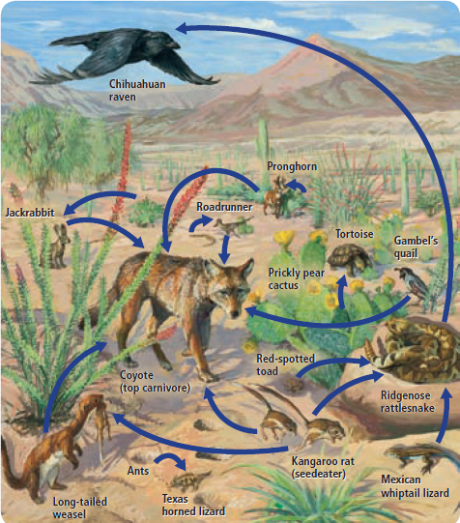
FOOD WEB (10 organisms total)
-include your favorite animal & at least 5 other animals
-at least 3 producers
-at least 1 decomposer or detritivore
-show how an animal can eat multiple things
- arrows indicating accurate flow of energy
- labeled with the following vocabulary; each organism should be labeled with both (or three) names:
producer, autotroph, consumer, heterotroph, herbivore, omnivore, carnivore, decomposer, detritivore
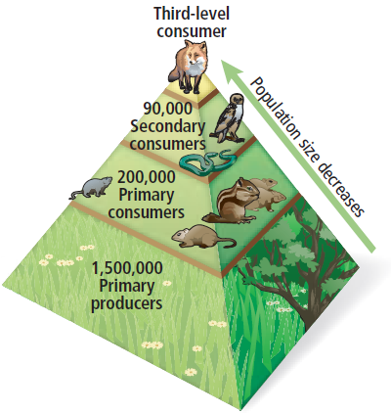
ECOLOGICAL PYRAMID
-Must visually represent your favorite animal’s habitat (it should LOOK like that terrain)
-should indicate Energy loss from bottom to top (use representative numbers)
-should contain at least four levels
-Label each level using the following terms for the levels: producer, primary consumer, secondary consumer, tertiary consumer

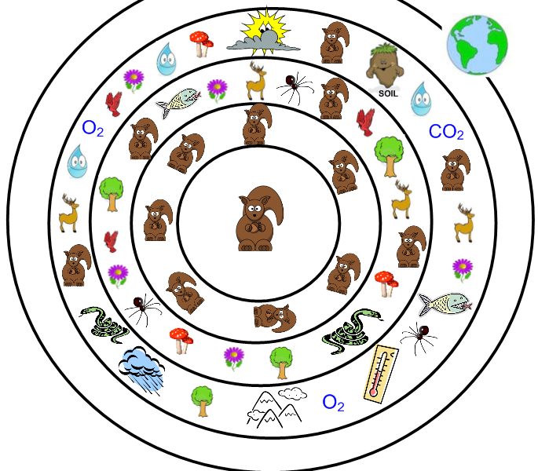
BIOLOGICAL LEVELS OF ORGANIZATION
-Follow the example we used in class (like a dartboard)
-use your favorite animal at the organism level in the center
-continue outward to the biosphere level by including the appropriate things in each level.
-label each level appropriately:
organism, population, community, ecosystem, biosphere

My Favorite Animal Ecology Poster Grading Rubric
Name: _________________________ Per: ____
Food Web:  - Title  - Fav Animal + 5  - 3 producers  - 1 decomposer/detritivore  - arrows in the correct direction  - Labeled: (producer, consumer, autotroph, heterotroph, herbivore, omnivore, carnivore)  Total | __ / 1  __ / 1  __ / 1  __ / 1  __ / 1  __ / 7  __ /12
Ecological Pyramid:  - Title/Represents habitat  - Did you include 4 levels?  - example numbers at each level  - Labeled: (producer, primary consumers, secondary consumers, tertiary consumers)  Total | __ / 1  __ / 1  __ / 1  __ / 4  __ / 7
Levels of Organization:  - Title  - 1 pt per level  - labels  - pictures in each level  Total | __ / 1  __ / 4  __ / 2  __ / 4  __ / 11
Total Points: | ___ / 30

